Volunteering information leaflet

Volunteers will play a vital role in achieving our vision of a world without MND.

By volunteering, you can have a huge impact on people living with motor neuron disease (MND.) That can be through committing time to support fundraising events or raising awareness of this brutal disease in local communities.

We will have a range of opportunities throughout the year for volunteers to engage. The more people we have signed up, the more we can do to support people with MND and make time count.

So, if you are considering volunteering with us, please get in touch by emailing volunteer@mndscotland.org.uk. We can then share more about our volunteering programme, how we will support you as a volunteer and the opportunities we have for you to get involved with.

Why volunteer with MND Scotland
- Make a difference - Your support makes our work possible in changing the lives of people with MND.
- Rewarding - Volunteering is an extremely rewarding activity.
- Meet new people - You will have the chance to meet other like-minded volunteers and form long-lasting relationships.
- Learn new skills - MND Scotland will support you through training, upskilling and support throughout your volunteering journey with us.
- Improve your wellbeing - Volunteering has been proven to improve mental health, physical health, and confidence.

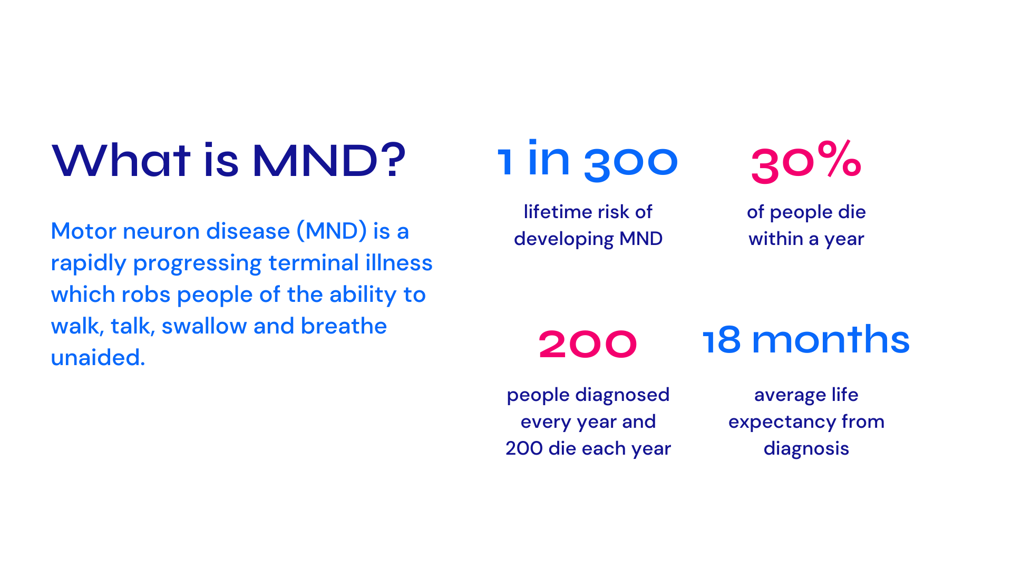
What MND Scotland do
Our vision is a world without MND. Until that day comes, we’re a helping hand of support, so people affected by MND can make precious time count with the ones they love.
We are the only MND charity in Scotland providing direct support to individuals and families throughout their MND journey, and in bereavement.
We offer wellbeing, financial and practical support to people living with MND in Scotland and the loved ones caring for them.
- We support – to make living with MND easier.
- We invest in research – to find meaningful treatments and a cure.
- We campaign – to fix a broken system.
- We champion – to build belief in our cause.
- We fundraise – to change lives today and bring hope for the future.

How MND Scotland will support you as a volunteer
- Training - MND Scotland will provide training for you to be able to confidently volunteer with us.
- Support and guidance - MND Scotland is committed to supporting and guiding our volunteers. This includes 1:1 check ins as well as peer support.
- Expenses - MND Scotland will provide expenses for volunteers.
- Recognition - MND Scotland deeply value and appreciate the work of our volunteers.

Volunteering activities
MND Scotland has a range of volunteering opportunities to engage with, depending on what you are most interested in. Below is a list of ideas, but this list if not limited and if you have any other ideas of skills, you’d like to share with MND Scotland, please let us know.
- Fundraising and events.
- Community ambassadors.
- Administration.
- Employee supported volunteering.

Here is a breakdown of the volunteer process step-by step:
- Fill in a volunteer interest form.
- Have an informal meeting with an MND Scotland staff member.
- Provide references.
- Sign a volunteer agreement.
- Attend induction training.
- You are ready to volunteer!

How to apply and find out more information
You can contact our volunteer coordinator at volunteer@mndscotland.org.uk to let us know that you are interested or thinking about volunteering with us. You can also fill in the volunteer registration form on our website.

